Stamp / Data-Structure Coupling

📌 Definition:
# Source: AI Source: Provided by: [Data Path: Persons Table -> ID Column: 1, Name_En Column: Motasem Essam] -> From: [Chatgpt (GPT‑5 Mini)] on [12/9/2025]
Stamp Coupling (also called Data-Structure Coupling) occurs when modules share a composite data structure (like an object or struct), but only some of the data is actually used.

🧠 Simple idea:
# Source: AI Source: Provided by: [Data Path: Persons Table -> ID Column: 1, Name_En Column: Motasem Essam] -> From: [Chatgpt (GPT‑5 Mini)] on [12/9/2025]
“Modules pass big objects, but only use a part of them” ⚠️

🔍 Key characteristics:
# Source: AI Source: Provided by: [Data Path: Persons Table -> ID Column: 1, Name_En Column: Motasem Essam] -> From: [Chatgpt (GPT‑5 Mini)] on [12/9/2025]
- Modules depend on the structure of shared data
- ❌ Can lead to tight dependency on internal fields
- ❌ Reduces clarity and maintainability
- ⚙️ Can be improved by passing only the required data

📊 Example of Stamp Coupling (Bad Practice):
# Source: AI Source: Provided by: [Data Path: Persons Table -> ID Column: 1, Name_En Column: Motasem Essam] -> From: [Chatgpt (GPT‑5 Mini)] on [12/9/2025]
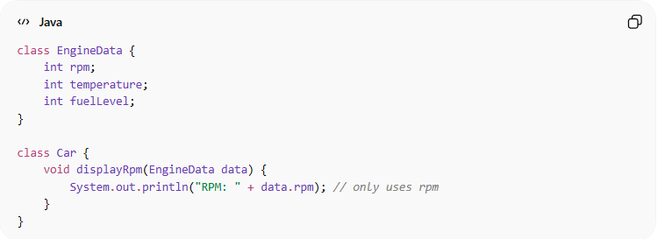
class EngineData {
int rpm;
int temperature;
int fuelLevel;
}

class Car {
void displayRpm(EngineData data) {
System.out.println("RPM: " + data.rpm); // only uses rpm
}
}
- ✅ Car receives the full EngineData object, but only uses rpm
- ✅ Changes to temperature or fuelLevel in EngineData could affect Car unnecessarily

🛡️ Avoiding Stamp Coupling Example:
# Source: AI Source: Provided by: [Data Path: Persons Table -> ID Column: 1, Name_En Column: Motasem Essam] -> From: [Chatgpt (GPT‑5 Mini)] on [12/9/2025]
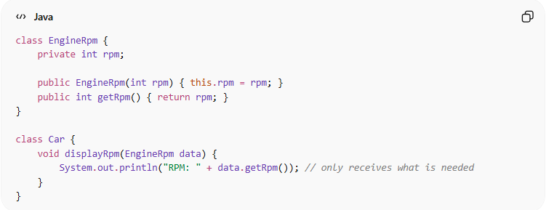
class EngineRpm {
private int rpm;

public EngineRpm(int rpm) { this.rpm = rpm; }
public int getRpm() { return rpm; }
}

class Car {
void displayRpm(EngineRpm data) {
System.out.println("RPM: " + data.getRpm()); // only receives what is needed
}
}
✅ Key improvements:
- Pass only the necessary data (rpm)
- Reduces dependency on unrelated data
- Improves clarity, maintainability, and modularity

⚙️ Best Practice:
# Source: AI Source: Provided by: [Data Path: Persons Table -> ID Column: 1, Name_En Column: Motasem Essam] -> From: [Chatgpt (GPT‑5 Mini)] on [12/9/2025]
- Avoid passing entire data structures if only part is used
- Pass specific values or minimal objects
- Keep modules independent of unrelated data
- Use encapsulation to hide unnecessary fields

